RESUME

LIJU THOMAS

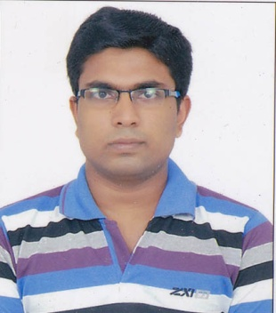 PATHARATHIL(H)

CHERUKULANJI P.O

RANNI

MOBNO:7025175329

lijuthomas1509@gmail.com

CAREER OBJECTIVE

To earn a job in a successful company to achieve personal goals through sincere hardwork with utmost dedication and responsibility for the upliftment of the institution and thus work actively in a team.

EDUCATIONAL QUALIFICATIONS

|  |  |  |  |
| --- | --- | --- | --- |
| COURSE | INSTITUTION | % OF MARKS SECURED | YEAR OF PASSING |
| X | JAWAHAR NAVODAYA VIDALAYA PATHANAMTHITTA | 100% | 2013 |
| XII | JAWAHAR NAVODAYA VIDALAYA PATHANAMTHITTA | 88% | 2015 |
| Btech cse | sct pappanamcode |  | 2020 |

TECHNICAL SKILLS

-Languages:c,cpp,Python,,Java

-Operating Systems:Linux,Windows xp/7/8/10

-Web Application:HTML

ADDITIONAL INFORMATIONS

*Attended 1 day Big data workshop held at college ,2016

Attended 1 day Firebase workshop held at college ,2016

PERSONAL SKILLS

*Adaptable to any environment

*Hardworking and sincere

*Excellent leadership skills

*Willing to learn and improve new talents

CO-CURRICULAR ACTIVITIES

*member of IEEE Computer Society

PERSONAL PROFILE

Fathers Name : THOMAS PV

DOB :15TH Sep 1996

Gender : Male

Nationality : Indian

Linguistic Talent : English(l,s,r,w,t,),Hindi(l,s,r,w,t),Malayalam(l,s,r,w,t)

Leisure Interests : Reading,Travelling,studying new things .

REFERENCES

1.Dr.sonia

HOD,CSE Dpt.

SCT

pappanamcode

DECLARATION

I hereby declare that the informations provided are correct upto my knowledge and will stick onto the rules and regulations of the institution andI bear the responsibility for the correctness of above-mentioned particulars.

Place:RANNI LIJU THOMAS